

Assignment 7

Network Security

Soheil Shirvani 3720505



# $volatility -f stuxnet.vmem imageinfo$, Provide a screenshot for the output of the above command.

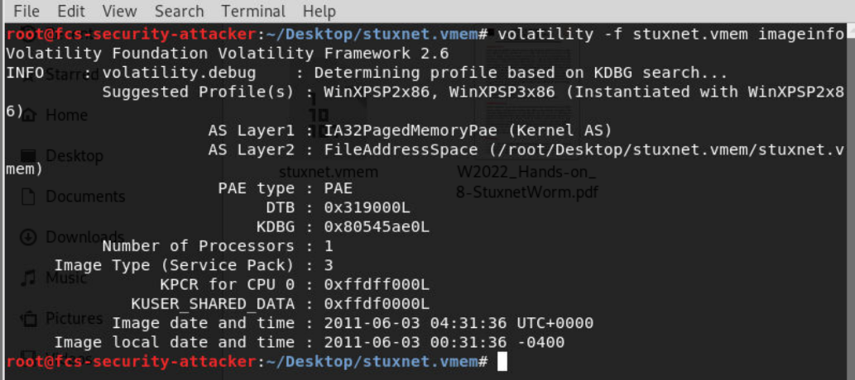

# $volatility -f stuxnet.vmem --profile=WinXPSP2x86 pstree$, List all the existing process IDs (PIDs) and parent process IDs (PPID) for running lsass.exe process. Do you think having lower PID and process’s data and time can be helpful to distinguish safe from unsafe processes?

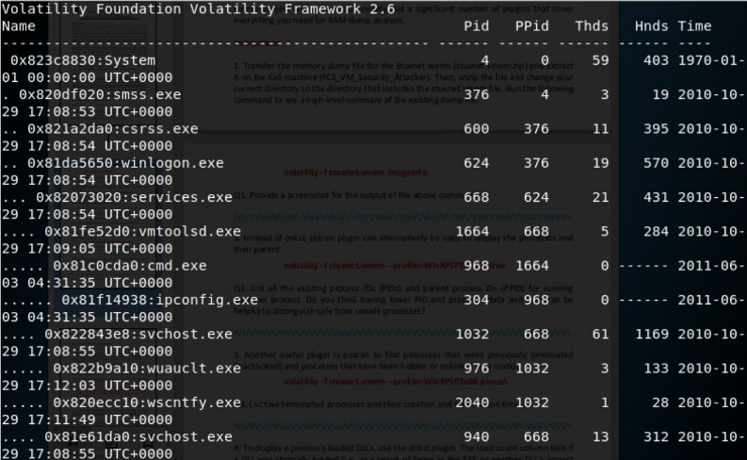

lsass.exe process:

|  |  |  |  |
| --- | --- | --- | --- |
| **Offset(P)** | **Name** | **PID** | **PPid** |
| **0x0000000001e47c00** | **lsass.exe** | **1928** | **668** |
| **0x0000000001e498c8** | **lsass.exe** | **868** | **668** |
| **0x0000000002070020** | **lsass.exe** | **680** | **624** |

There are 3 lsass.exe in the process list but there should be one lsass instance in the process list. For the first two rows the creation time is the same and for the last one is around one year earlier which is suspicious. Also, the PID for all these three processes are different which shows this file is a malicious file.

# $volatility -f stuxnet.vmem --profile=WinXPSP2x86 psscan$*, List two terminated processes and their creation and termination times*

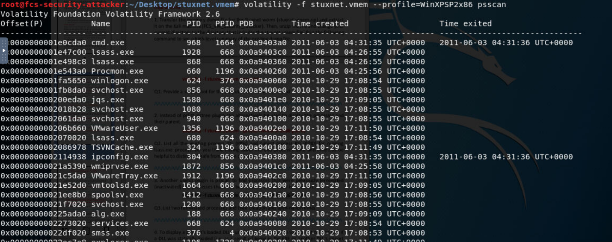

|  |  |  |  |  |  |  |
| --- | --- | --- | --- | --- | --- | --- |
| Offset(P) | Name | PID | PPID | PBD | Time\C | Time\E |
| 0x0000000001e0cda0 | cmd.exe | 968 | 1664 | 0x0a9403a0 | 2011-06-03 04:31:35 UTC+0000 | 2011-06-03 04:31:36 UTC+0000 |
| 0x0000000002114938 | ipconfig.exe | 304 | 968 | 0x0a940380 | 2011-06-03 04:31:35 UTC+0000 | 2011-06-03 04:31:36 UTC+0000 |

# $volatility -f stuxnet.vmem --profile=WinXPSP2x86 dlllist$, What is load count for static and dynamic DLL load in the output of the above command and how is it controlled?

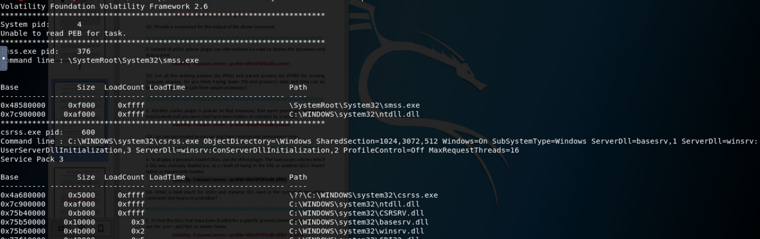

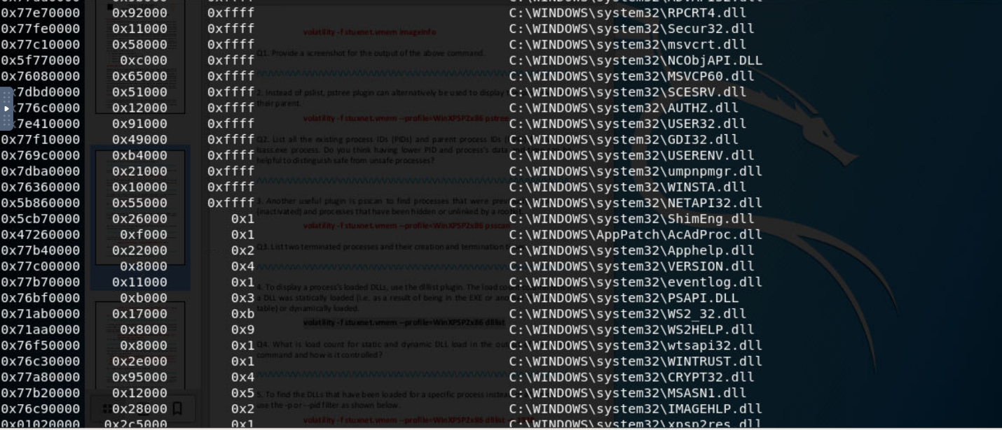

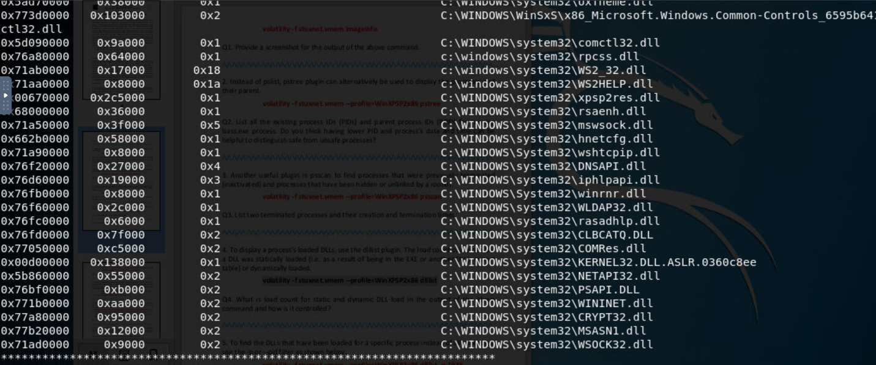

# $volatility -f stuxnet.vmem --profile=WinXPSP2x86 dlllist -p 1928$, *Provide the output of the previous command.*

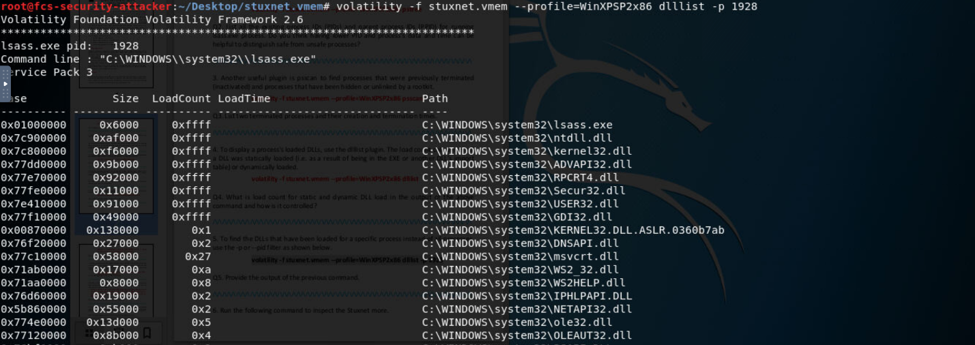

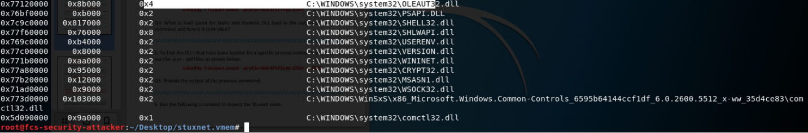

$volatility -f stuxnet.vmem –profile=WinXPSP2x86 pstree | egrep$

# $'(services.exe|lsass.exe|winlogon.exe)' | tee pstree.txt$

# , *Provide the output of the previous command*

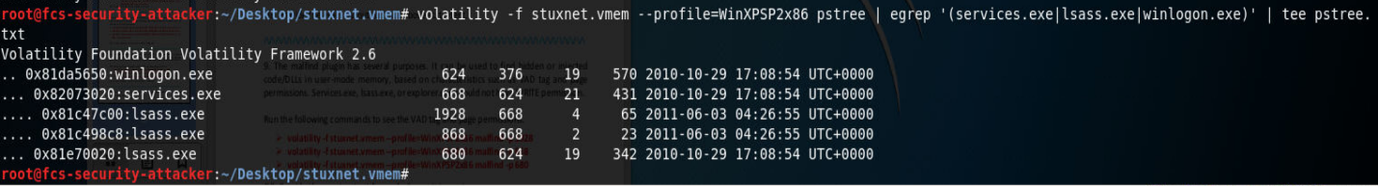

# $volatility -f stuxnet.vmem --profile=WinXPSP2x86 sockets | egrep '(Off|--- |680|1928|868)' | tee sockets.txt$, *Provide the output of the previous command.*

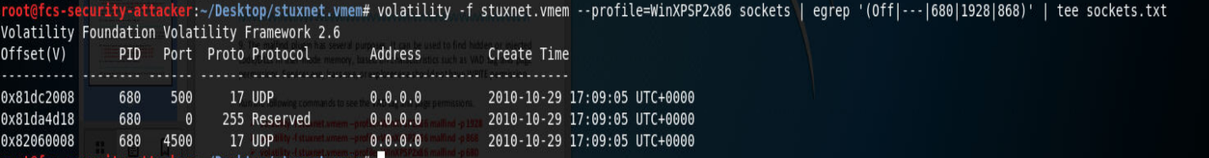

# 







# 

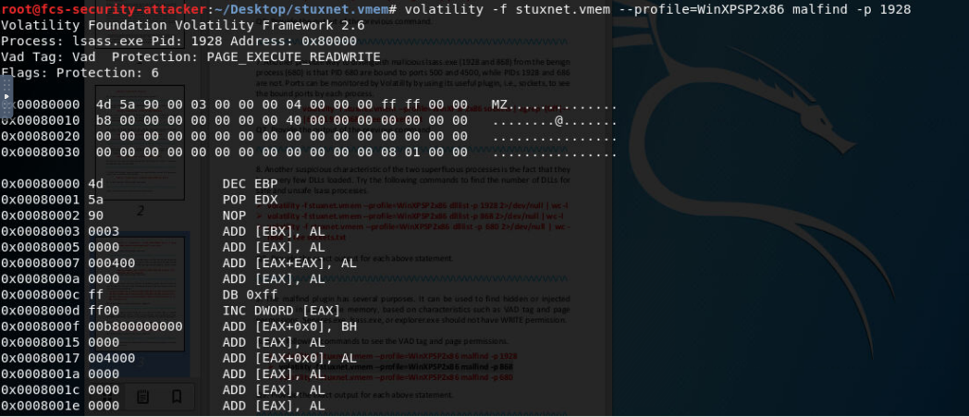

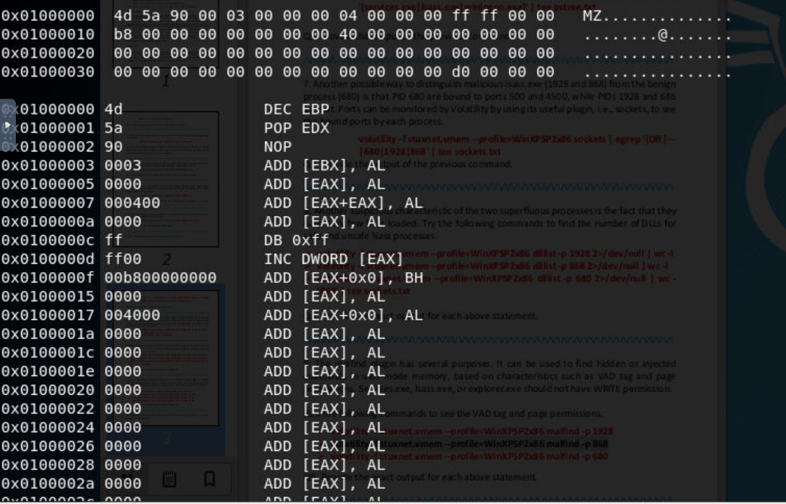

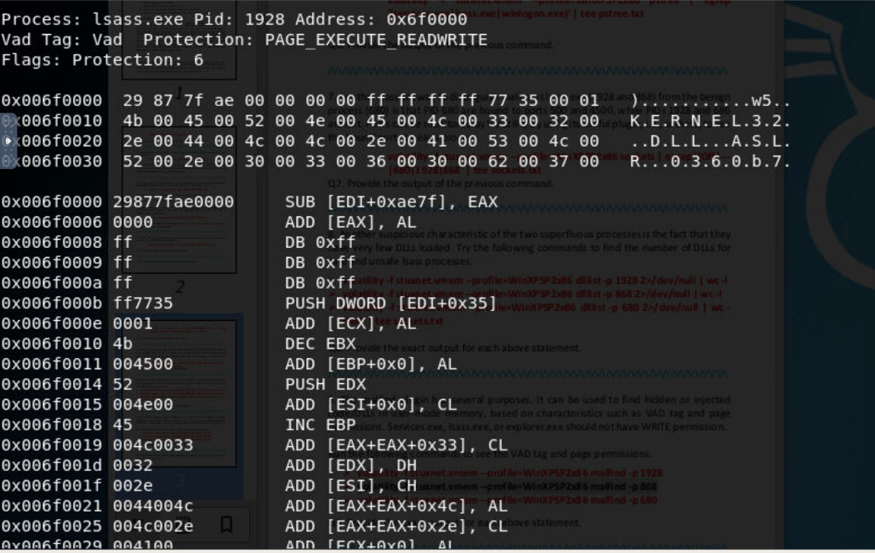

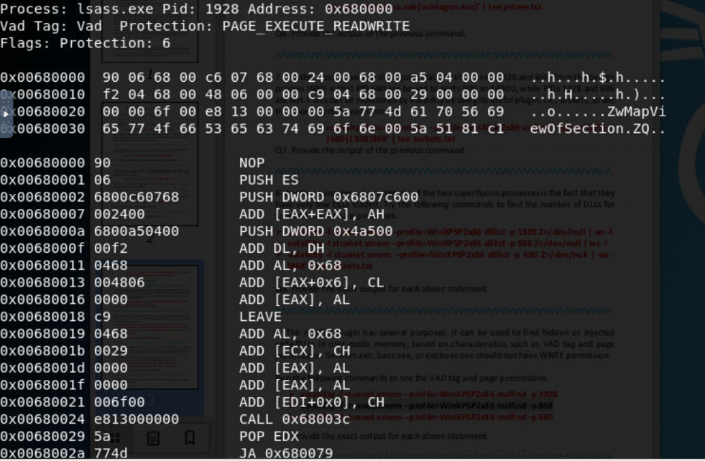

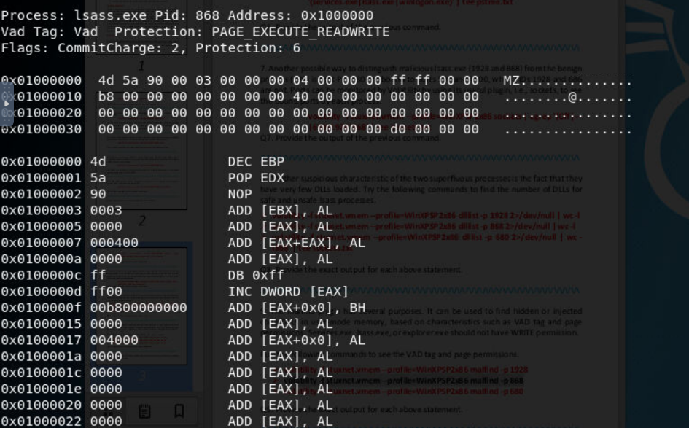

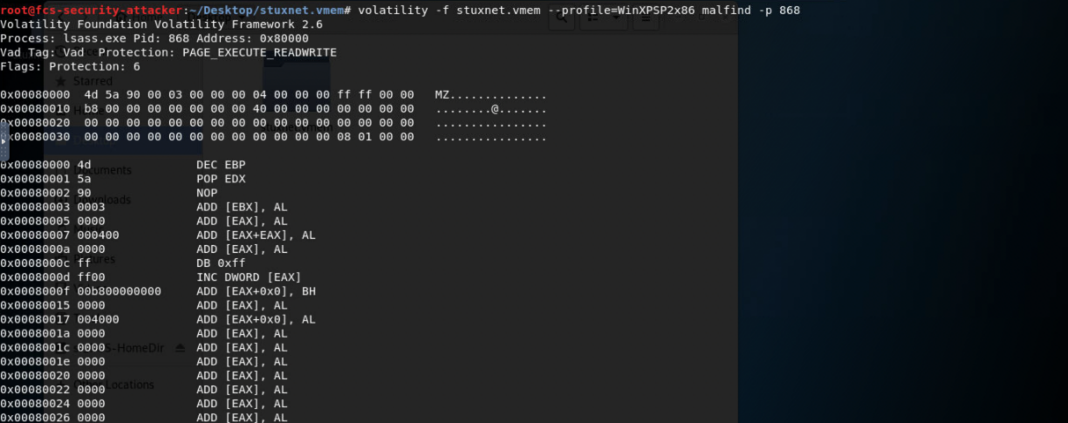

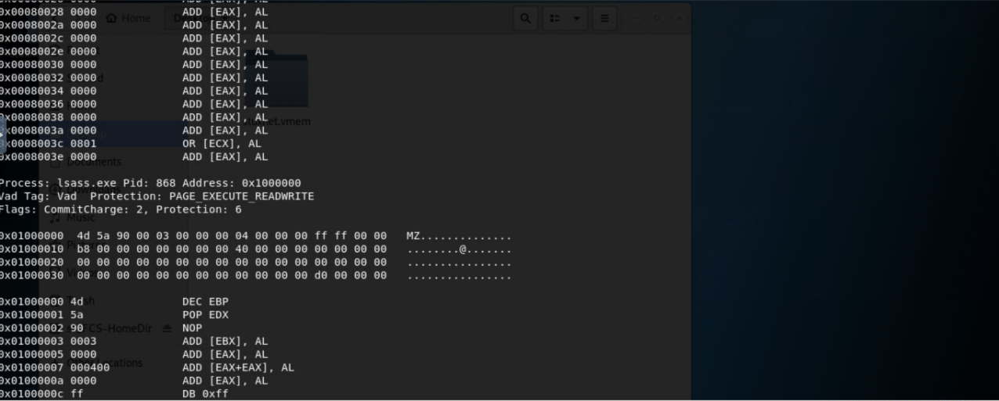

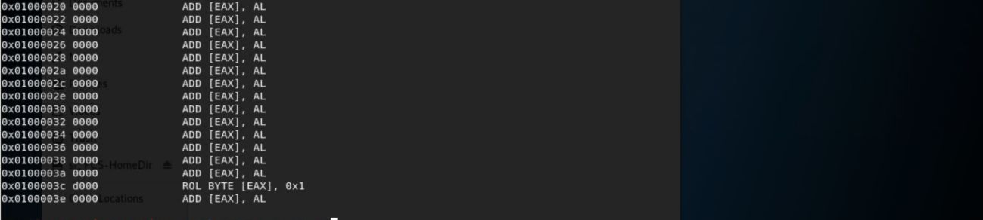



# Explain the hook injection technique and briefly explain how volatility can be applied to detect malicious hooks.

Hook injection describes a way to load malware that takes advantage of Windows hooks, which are used to intercept messages destined for applications. Malware authors can use hook injection to accomplish two things: To be sure that malicious code will run whenever a particular message is intercepted, to be sure that a particular DLL will be loaded in a victim process’s memory space.  users generate events that are sent to the OS, which then sends messages created by those events to threads registered to receive them. The right side of the figure shows one way that an attacker can insert a malicious DLL to intercept messages.

The plugin dlllist in the Volatility Framework can also be used to list all DLLs for a given process in memory and find DLLs injected with the CreateRemoteThread and LoadLibrary technique. This technique does not hide the DLL and therefore will not be detected by the plugin malfind. The first command well use is the malfind command. This command is used to find injected code inside the processes memory. It does this by looking for sections of allocated memory ( by looking at the VAD tree data structure) and checking if they have hints of executable code that are not mapped to any file on the disk